SOL 4.4 Test on Multiplication Study Guide
Vocabulary:

Multiplication: a math operation where a number is added to itself a number of times
4 + 4 + 4 + 4 + 4 = 20 OR 5 X 4 = 20
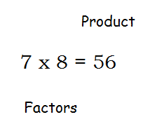
Factor: a number that is multiplied by another number to find a product

Product: the answer to a multiplication problem.

Multiple: the product of a given number and another number.

4 x 2 = 8
8 and 12 are multiples of 4
4 x 3 = 12

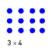
Array: data organized using rows and columns

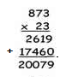
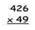
We will learn that there are different ways to determine the product of a multiplication problem.
- Traditional Algorithm

- Box Method:
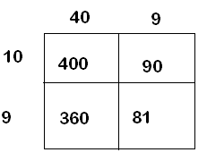
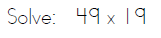

400+360+90+81 = 931 ____ +____+____+____ =______

Pick an above method to solve the following word:
There are 32 boxes that Ms. Johnson needs to ship. Each box holds 357 books. How many books will Ms. Johnson be able to send?

Multiplication Using Estimation: Estimate the following products.
Helpful hint: When you're multiplying by multiples of 10 you can multiply the counting numbers and then add the 0's to the final answer.
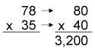
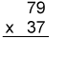

Derek bought 26 boxes of chocolates. There were 64 chocolates in each box. About how many chocolates did Derek buy?

